New AFS Positive Pay Activation Instructions
- To activate your account, you’ll receive an email from Compeer Financial (noreply@id.compeer.com). Click the Activate Okta Account link in the
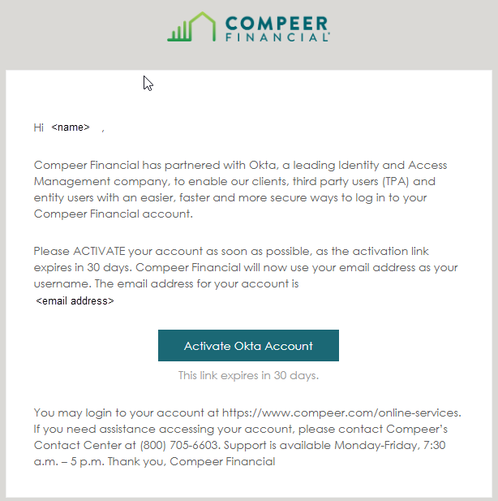

- Set up security methods. Need to setup Password and Phone
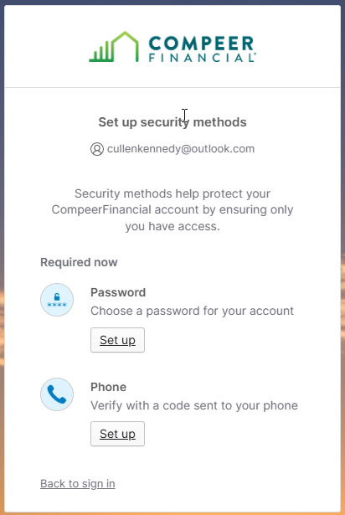

  - Set up Password – Enter and confirm you password.

  - Set up Phone – Enter your phone number, select whether you want to receive an SMS text or Voice call, and click Receive a code link. Then, enter code sent to your phone.
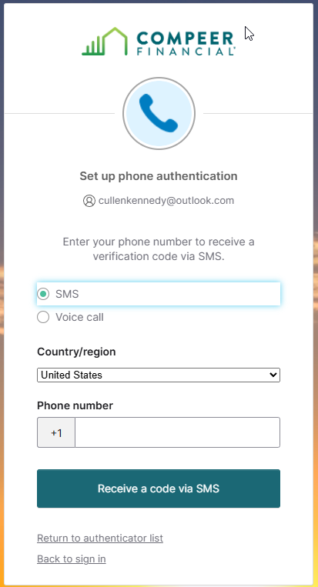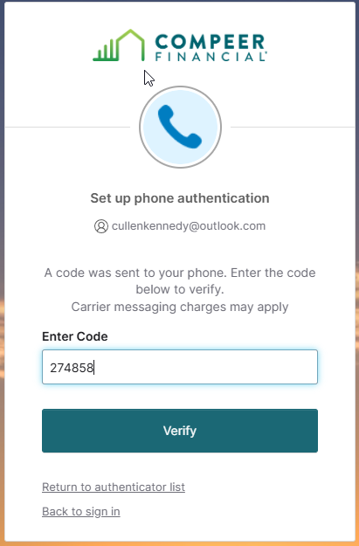

- Okta Verify (Optional) – To set up Okta Verify, download from the app store and follow the directions on screen.
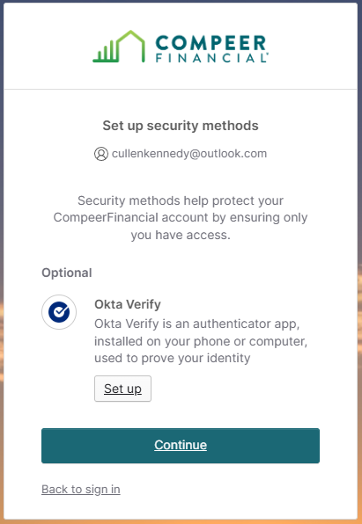

- Activation of your account is complete – you’ll be redirected to the Online Services page. You can now log into Online Banking as normal to access the new AFS Positive Pay. Login instructions continued below.
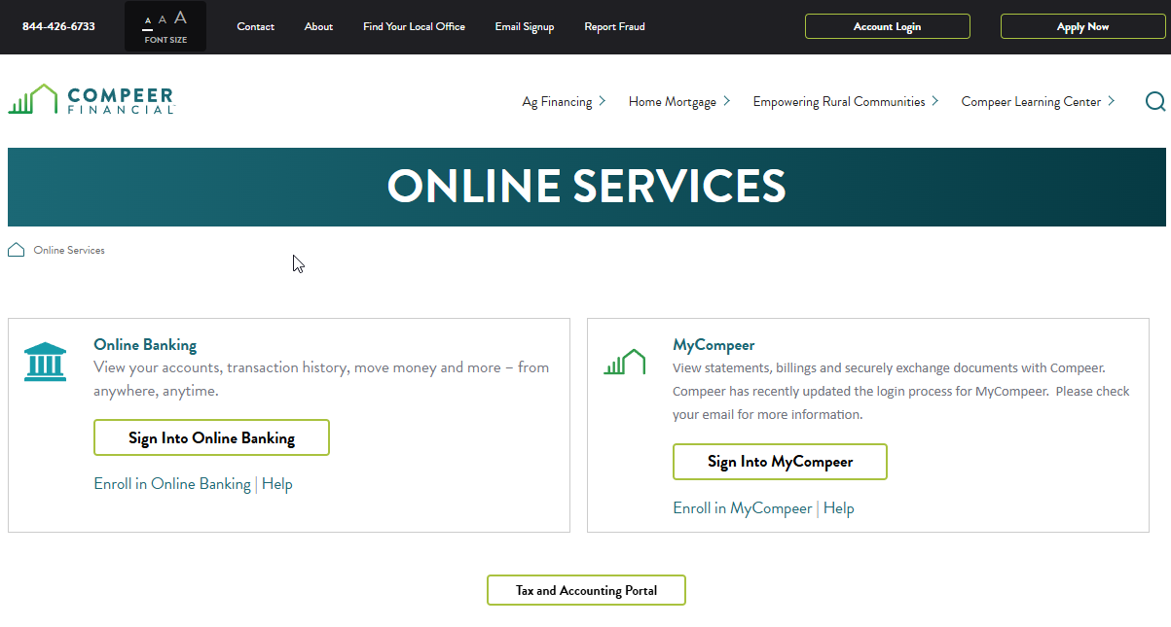

New AFS Positive Pay Login Instructions
- Once logged into Online Banking, access the New AFS Positive Pay under the Accounts tab.
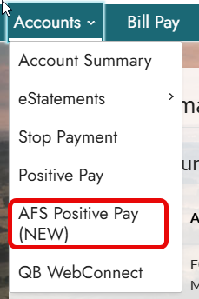
NOTE: Prior to your Go-Live date, you’ll see links to both Positive Pay platforms. Continue to use the Positive Pay link to upload and decision exceptions. The AFS Positive Pay (NEW) link will be available a few days before your Go-Live date so that you can access and familiarize yourself with the new system. On you Go-Live date, you’ll no longer see the original Positive Pay link.

- After clicking on the AFS Positive Pay (NEW) link, you’ll be prompted to login. Begin by entering your Email Address.
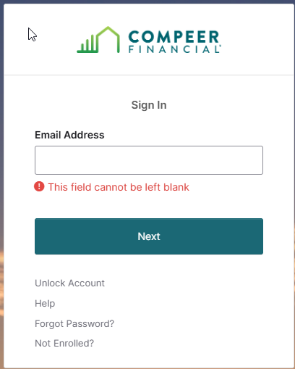
NOTE: Work continues to provide a single, integrated platform under a single sign-on. Once that happens, you’ll only authenticate once to access both Online Banking and Positive Pay.

- Login using your Password (or choose Email to receive a code).

- After you enter your password, verify your identity using Phone or Email (or Okta Verify if you opted for that method). Screenshots below are for Phone verification.
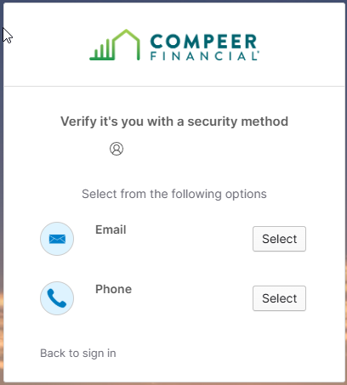

- If using Phone, choose whether to receive an SMS or voice call. Enter the code received to complete authentication.
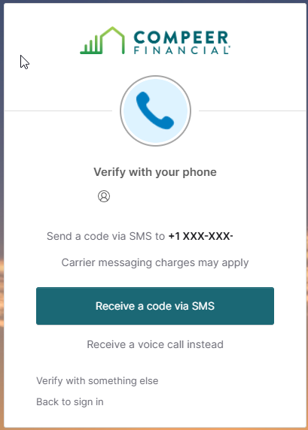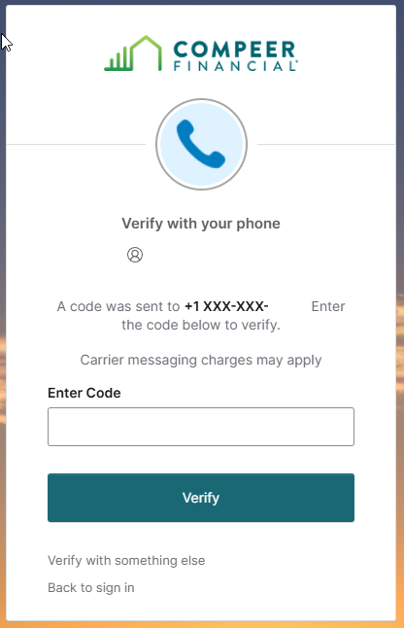

New AFS Positive Notification Settings
NOTE: You must set up Notification Settings in order to receive notifications when there is a draft that needs a decision.
- Once logged in to the new Positive Pay system, click your name in the upper, right-hand corner of the page and select My Info.
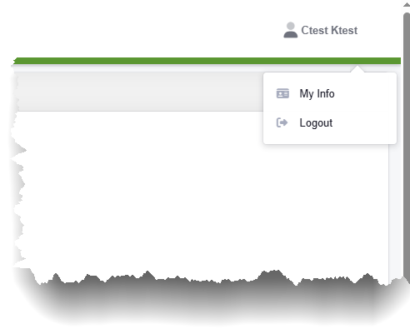

- To receive New Exception notifications, toggle the button under Immediately to On and/or set the Time Interval to receive frequent reminders when there are exceptions pending a decision.

Next, select a Notification Method (Email, Text Message or both), then click Update My Info.
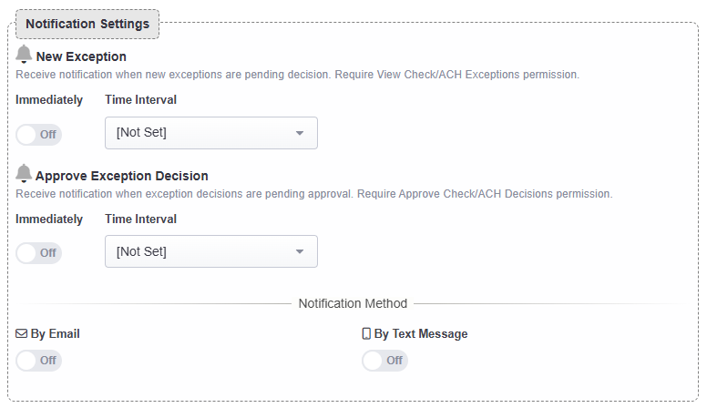
Note: Notifications for Approve Exception Decision is only necessary if you require multiple approvers for exception decisions.

